Name: Prateek Sachan
Enrollment No.: 18114056
Branch: Computer Science and Engineering
Subbatch: O2

Problem Statement 1:
Problem Statement 1: Create a dictionary using Trie data structure (without using STL) having words and their meanings. You need to read the words and their respective meanings from a CSV file (uploaded in Piazza, named as TrieInput.csv), where 1st column is for words and 2nd column shows its meaning.Given a word you have to print its meaning. If no such word is found in the dictionary, then print “Invalid word”. Create a GUI using Qt library to accept a word in a text box and display the meaning in an anotherbox, as shown in the Figure 1.Also,create an installer of your program for Windows OS. You can use the software like InstallSimple or InstallShield or WIX or NSIS to do so.
Data Structures Used:
- Tries
- Array
- Maps

Algorithm Used:
- Insertion: Traversed through string and corresponding tree nodes and marked node as true at the end of word.
- Search: Traversed through string and corresponding tree nodes and looked for node with true value.

Screenshot:

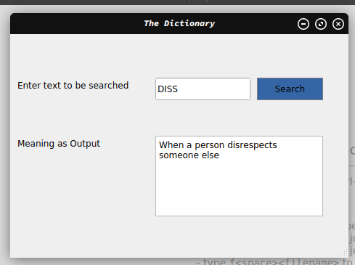

Problem Statement 2:
Implement N Queens problem to show all the possible combinations in N x Nbinary matrix and to display the total number of such combinations at the end, where 1 represents the position of N queens in theN x N matrix and remaining cells are represented by 0.

Data Structure Used:
- Array

Algorithm Used:
- Backtracking: For every row, return backed to that row if solution with that configuration is not possible.

Screenshot:
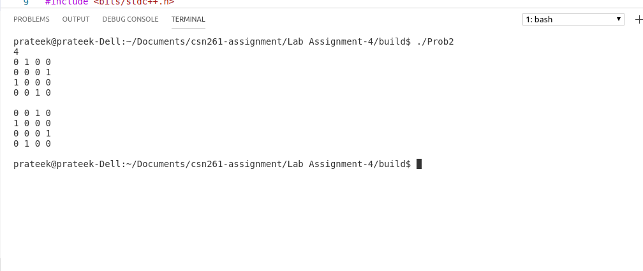
CPU Time:
0.007s

Problem Statement 3:
Given an integer array having N number of elements, write a C++ programusing hash map (using STL) to find the length of the largest subarray from the given input array, where thesummation of the elements of the subarray is equal to n. In the output, if any solution exists then print the starting and ending index (with respect to given input array) of the largest subarray and also print its length. Otherwise, print “Not Found”, as described in the following output.

Data Structure Used:
- Unordered Maps

Algorithm Used:
- Stored the continous sum and corresponding index in the map and performed order1 lookup using map.

Screenshot:
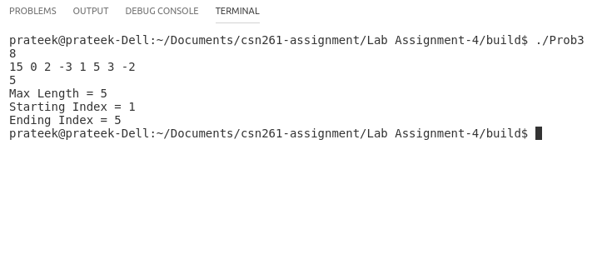
CPU Time:
0.001s

